Solution Architecture Document
Sensei 1.0
Date completed: 7/25/2025
Last Updated: 7/29/2025

Document management history
Revision history
The following table summarizes the revision history for this document.
Date | Version | Architect | Author/Title | Revision summary
07/25/2025 | 1.0 | Elton Trotman | Solution Architecture | First Draft

Contents
Solution Architecture Document 1
Document management history 1
Introduction 4
Executive summary 4
Document Purpose 4
Architectural goals 5
Architectural Significant Requirements 7
Architectural Patterns and Models 8
Original Premise and Architecture 8
Sensei Solution Architecture 9
Sensei Architectural Solutions 10
API Scaling Issues 10
Workflow 10
Event Consolidation and Logging 11
Message Loss 11
UI Response to Asynchronous Requests 11
Architecture Scaling 11
Key Patterns and Resources 12
Service Bus Utility 12
Dead Letter Queueing 13
Service Bus Asynchronous Processing -Asynchronous Request-Reply 14
Web Pub Sub 15
Async HTTP APIs (Durable Functions workflow) 16
Event Consolidation and Tracking 17
17
Microservice Patterns 18
Overall Design 18
DDD 19
CRQS 20
Circuit breaker 21
Bulkhead 22
Saga 23
23
Strangler Fig 24
Aggregation 25
Gateway Routing 26
Queue Based Load Leveling Pattern 26
Cross-cutting Components 27
Network Considerations 28
28
Risks 29
DB Risk: Monolithic Schema Design 29
Risks for Microservices 29
Risk for Event Driven Systems 29
Architectural Compromises and Mitigation 30
No Containerization 30
No Gateway Offloading 30
No Message Bridge 30
No Backends for Frontends 30
No Event Sourcing 30
Testing 30
Stress Testing 30
Load Testing 31

Introduction
The goal of this Technical Architecture is to define the technologies, products, and services necessary to develop and support the system, and to ensure that the system components are compatible and comply with the enterprise-wide standards and services.
The objective of the Sensei program is to provide an architecture that achieves:
- high scalability both horizontally and vertically,
- event driven
- introduces microservices to the current monolithic architecture
The expected business outcomes include:
- The current system will scale as demanded by SEAA requirements
- The system can perform underload at the presentation, middle and data layers
- Less reliance and significant cost reduction on the service provider (Azure) to achieve scalability and performance.
- The architecture will be able to scale more easily.

Executive summary
Sensei is an architecture that allows for increased scaling and performance as the K12 program needs grow. With modern architectures, Sensei will be able to meet those needs.

Document Purpose
This document provides a comprehensive architectural overview of the system. It conveys the significant architectural decisions and focuses on providing:
- A description of the solution architecture, including major components and their interactions, processes, and data.
- A common understanding of the drivers (constraints and principles) influencing the architecture.
- Explanation of how the architecture satisfies the drivers.

Problem Domain
- The original architecture proposed
  - The architecture approved by CFI from Randstad was intended to resemble a microservice architecture complete with service bus, event grids and a domain driven design.
- CFI stated existing application does not scale and fails under concurrency load
  - We were able to procure the following concurrency numbers from CFI:
    - A maximum of 80k concurrent users over an hour span.
    - The time frame from max users is early March
- Broad Performance issues

Architectural goals
- Scalability
Beyond Vertical scaling is often necessary, introducing horizontal scaling provides benefit.
- Always Secured
Limit access at presentation, business logic and data access layers. Use security controls at Web Apps, Web APIs, Microservices, SQL DB, BLOB Containers, to define security limitations.
- Consolidation of events
Events from external webhooks, posts, routed via Event Grid/Service Bus should be centralized
- Minimal Access
Each service has access to only those resources it needs at the level it needs.
one should "depend upon abstractions, [not] concretions."
- Tracing, Logging and Auditing
Trace everything, log decisions, audit actions. Make it useful, traceable, and fast.
- Network isolation
Each component of the solution will be isolated by VNETs with Private end points
- High Availability
The solution will be designed according to high availability principles.
- Input Validation
Input validation will be performed at client and server sides.
- Input will never have any unsecured content.
- Asynchronous
Implement code asynchronously. No waiting or blocking.
- Performance
The platform will be performant at the middle and data layers according to client requests
- Downtime
Platform will not fail under load according to client’s concurrency user requirements

- Best Coding Practices
  - Simple & SOLID & DDD
Keep it simple, maintain single responsibility, and follow domain driven design principles.
  - Single responsibility principle
“a class should have only a single responsibility (i.e. changes to only one part of the software's specification should be able to affect the specification of the class).”
  - Open/closed principle
"Software entities … should be open for extension but closed for modification."
  - Liskov substitution principle
"Objects in a program should be replaceable with instances of their subtypes without altering the correctness of that program."
  - Interface segregation principle
"Many client-specific interfaces are better than one general-purpose interface."
  - Dependency inversion principle

Architectural Significant Requirements

Non-Functional Requirements
Concurrency | Platform will provide concurrent processing for Project data within the allotted SLA for data size of the engagement.
Logging | The platform will provide logging and tracing capabilities. The platform will provide log viewers with logged information.
Encryption | The platform will encrypt data at rest and at transfer. Platform will additionally encrypt C3+ data in metadata.
Reusability | Platform will support reusability across entire solution
Maintainability | Platform will keep maintainability
Flexibility | Platform will be extensible and flexible
Exception Handling | The platform will be catching all the exceptions across the system.
Scalability | The platform will have the capability to scale both Horizontally and Vertically
Performance | Platform will be performant within the stated parameters and requirements from the client
Concurrency | Platform will process multiple users simultaneously

Architectural Patterns and Models

Original Premise and Architecture

The Original Premise and Architecture is fairly widespread and addresses issues such as reliability, distribution, and coupling. The monolithic architecture currently in place does not address scaling, reliability, and flexibility at large.
Expanding upon the original architecture and augmenting the current architecture in place, Sensei looks to address:
- Asynchronous Processing
- Scaling Capabilities
- Message Reliability
- Event Consolidation
- UI Capability to Respond to Long Running and Asynchronous Requests

Sensei Solution Architecture
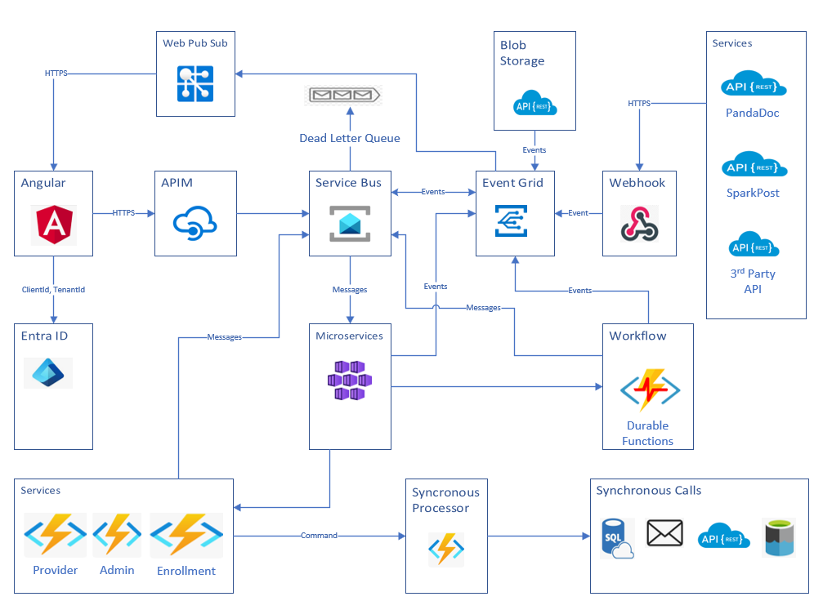
This architecture allows for a central messaging hub and event consolidation for applications via an Event Grid. This decouples the application from processing requests synchronously and defers synchronous processing to queue workers. The service bus allows for decoupling, reliable messaging, scalability and async communication. Microservices are a key architectural component, and sensei has the beginnings of a robust Microservice Pattern

Sensei Architectural Solutions

API Scaling Issues
Sensei offers options for handling compute/data intensive calls. From the client these calls can cause downtime in the application. The system crashed specifically with high demand.

Asynchronous Call Options
- Sensei has addressed compute and/or data intensive synchronous bottle necks by establishing queues to offload synchronous calls. Messages are processed off queue and can be prioritized. This relies on the Asynchronous Reply-Reponse pattern as well as web PuB Sub. An alternative to web Pub Sub is the more antiquated https polling pattern that is tried and true yet less elegant and efficient.
  - Pros – Message Retry with dead letter queues, Priority Queueing, App Service Plan can change and scale
  - Cons - More complexity with Queueing
- Sensei has also offered a pattern for retrieving responses to asynchronous API calls. Sensei applies the Asynchronous Reply-Response patterns for potentially intensive calls. APIs can be called asynchronously to achieve this.
  - Pros – Less Complexity
  - Cons - Message Loss Possible, No Priority Queueing, No Compute control, coupled to app service plan of App Service, no event tracking

Workflow
Sensei also offers options to handle long running functions:
- Sensei utilizes durable functions to manage long running calls. There is built in support for workflow utilizing this message.
  - Pros – Less Complexity
  - Cons- Message Loss Possible, No Priority Queueing, No Compute control, coupled to app service plan of App Service
- Sensei’s usage of queueing and the Asynchronous Reply-Response pattern addresses long running calls.
  - Pros – Message Retry, Priority Queueing, App Service Plan can change and scale, event tracking
  - Cons- More complexity with Queueing

Durable Functions Workflow
In Azure Durable Functions, a workflow defines a sequence of operations that can involve multiple steps, long-running tasks, and interactions with external systems. Unlike standard, stateless Azure Functions, Durable Functions introduce stateful execution, allowing workflows to pause, resume, and maintain their state across executions.
Key components that define a workflow in Azure Durable Functions:

Durable Task Framework:

This underlying framework manages the state and execution history of orchestrations in durable storage . It enables the "checkpointing" of workflow progress, allowing orchestrations to be resilient to failures and resume from where they left off.

Orchestrator Functions:

They define the logical flow and coordination of tasks. Orchestrator functions must be deterministic, meaning they always produce the same output for a given input, ensuring reliable replay and state management. They use a specific API to schedule activity functions, manage state, and handle external events.

Activity Functions:

These functions perform the actual work within the workflow. They are typically stateless and carry out discrete units of work, such as making API calls, interacting with databases, or processing data. Orchestrator functions invoke activity functions, and the Durable Functions runtime manages the execution and retries of these activities.

Client Functions:

These functions initiate the execution of an orchestrator function. They act as the entry point for the workflow, often triggered by external events like HTTP requests, queue messages, or timers. Client functions use the Durable Functions client API to start, query, and manage orchestration instances.

Event Consolidation and Logging
With Event Grid usage, Sensei not only delivers event-based architecture, but also the ability to consolidate events, be they 3rd Party (webhooks), custom application events or Azure triggers.

Message Loss
Sensei Offers dead letter queueing to retry messages that were unable to be processed. This is especially critical when under high load

UI Response to Asynchronous Requests
A combination of Web Pub Sub and the Asynchronous Response-Reply Pattern allows for the UI to respond to long running/compute intensive processes.
Implementing an Asynchronous Request-Reply pattern with Azure Web PubSub and an Angular client allows you to manage long-running server-side tasks without blocking the client's user interface. The Angular application sends a request, and a backend service handles the work, using Web PubSub to push the result back to the specific client connection when it's ready.
Architecture overview
3 main components:
- Angular: Initiates a request and uses the web-pubsub-client library to maintain a persistent WebSocket connection to Web PubSub, where it listens for a specific reply.
- Azure Web PubSub: A managed service that handles the WebSocket connections for you. It relays messages between the client and the backend application.
- Backend: code receives the initial request, starts the long-running task, and uses the web-pubsub server-side SDK to send the reply message back to the client.
Order of events
  - Client request: The Angular component calls webPubSubService.sendRequest().
  - Message to Web PubSub: The service client sends a message containing a correlationId to the async-replies group on the Web PubSub service.
  - WebHook trigger: Web PubSub, configured with an event handler, forwards the client message to your backend application's /api/message endpoint.
  - Backend processing: The backend server receives the message, extracts the correlationId and connectionId, and starts the long-running task. It immediately sends an HTTP 202 status back to Web PubSub to confirm receipt.
  - Task completion and reply: Once the backend task is complete, it uses the server-side SDK to send the result, along with the original correlationId, back to the specific connectionId on Web PubSub.
  - Reply delivery: Web PubSub forwards the reply message to the Angular client over the open WebSocket connection.
  - Client receives reply: The web-pubsub.service's message handler receives the reply. The RxJS filter operator ensures that only the message with the matching correlationId is processed, and the component's subscribe() block is triggered with the final result.

Architecture Scaling
Sensei has established a lightweight microservices pattern over monolithic to achieve horizontal scaling. Sensei will continually add more complex microservices pattern as the architecture matures. Currently sensei accounts for the core patterns to achieve a microservices architecture.

Resiliency
Dapr achieves failures and retries through its resiliency building block, which is configured declaratively using a YAML file. This approach decouples the resilience logic from code. Dapr applies these policies to transient failures that occur during communication between its sidecar and your application or other infrastructure components.
Core components of Dapr resiliency
- Resiliency spec: A YAML file, often named resiliency.yaml, where you define the specific policies for handling transient failures.
- Timeouts: Your first line of defense, timeouts prevent applications from hanging indefinitely while waiting for an unresponsive service. A request that exceeds the timeout duration will trigger the retry policy.
- Retries: If an operation fails, Dapr automatically reattempts the operation based on a configured policy. Retries are especially useful for handling temporary issues like network glitches or a service being temporarily unavailable.
- Back-off strategies: Dapr supports two main back-off strategies for retries to avoid overwhelming a struggling service with repeated requests.
  - Exponential back-off: Increases the delay between retry attempts exponentially. Dapr also adds jitter (random variation) to the delay to prevent a "retry storm" where multiple clients hit a recovering service simultaneously.
  - Constant back-off: Retries at a fixed interval.
- Circuit breakers: Inspired by the electrical component, this pattern prevents a failing service from causing cascading failures. After a configurable number of failures, the circuit "trips" and all subsequent requests fail immediately without even attempting to reach the unhealthy service. This gives the failing service time to recover.
Retries in specific Dapr building blocks
Service invocation
- Mechanism: When one Dapr sidecar makes a service-to-service call to another, Dapr's built-in logic automatically handles retries for failures like network connectivity issues or sidecar availability.
- Configuration: You can define custom retry policies in your resiliency spec and apply them to specific application targets to override the default behavior.
Pub/Sub
- Mechanism: Dapr uses a combination of its own resiliency policies and the message broker's built-in retry mechanisms.
- Dead letter queues: With supported components like Azure Service Bus, you can configure Dapr to send messages to a dead-letter queue after a certain number of failed processing attempts. This prevents "poison messages" from causing infinite retries.
Actors
- Mechanism: Dapr offers built-in retry logic for failures during the sidecar-to-sidecar communication for actor method calls. For durable actor state and reminders, retries are also built-in.
- Runtime exceptions: If an actor method throws an exception, the Dapr runtime logs the error but does not automatically retry the actor's method itself. For true durability, you must use persistent state and reminders to re-trigger the logic.
State management
- Mechanism: Dapr automatically retries requests to state stores, like saving or retrieving data.

Interservice Communication
Depending on the specific requirements for synchronous or asynchronous communication and the level of coupling desired between services.

Service Mesh (e.g., Dapr, Istio on AKS):
Dapr (Distributed Application Runtime)provides a dedicated infrastructure layer for handling interservice communication. Sidecar proxies are deployed alongside each microservice to manage communication.
Synchronous Communication:
HTTP/REST:

Microservices can directly communicate with each other using HTTP requests, often with RESTful APIs. This is suitable for scenarios where an immediate response is required. Azure Container Apps, for instance, facilitates this by providing internal DNS resolution for services within the same environment

Asynchronous Communication

Azure Service Bus:

This is a robust messaging service for reliable, asynchronous communication. It supports queues for point-to-point messaging and topics/subscriptions for publish-subscribe patterns, enabling decoupling between services.

Azure Event Grid:

A fully managed event routing service that allows services to react to events published by other services or Azure resources. It's ideal for event-driven architectures where services need to be notified of changes or actions

Key Patterns and Resources
Service Bus Utility
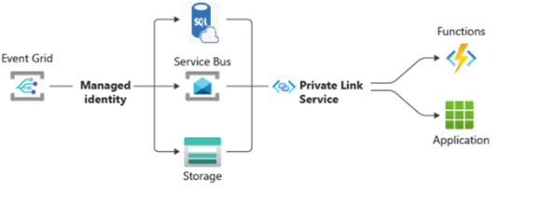
Azure Service Bus is a fully managed enterprise message broker with message queues and publish-subscribe topics.
- Load-balancing work across competing workers
- Safely routing and transferring data and control across service and application boundaries
- Coordinating transactional work that requires a high degree of reliability
- Data is transferred between different applications and services using messages.
Some common messaging scenarios are:
- Decouple applications. Improve reliability and scalability of applications and services.
- Transactions. Allows you to do several operations, all in the scope of an atomic transaction. For example, the following operations can be done in the scope of a transaction.

https://learn.microsoft.com/en-us/azure/service-bus-messaging/service-bus-messaging-overview

Dead Letter Queueing
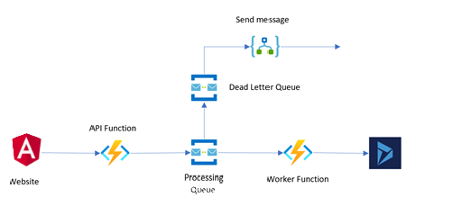

The purpose of the dead-letter queue is to hold messages that can't be delivered to any receiver, or messages that couldn't be processed. Messages can then be removed from the DLQ and inspected. An application might let a user correct issues and resubmit the message.
From an API and protocol perspective, the DLQ is mostly similar to any other queue, except that messages can only be submitted via the dead-letter operation of the parent entity. In addition, time-to-live isn't observed, and you can't dead-letter a message from a DLQ. The dead-letter queue fully supports normal operations such as peek-lock delivery, receive-and-delete, and transactional operations.
https://learn.microsoft.com/en-us/azure/service-bus-messaging/service-bus-dead-letter-queues

Service Bus Asynchronous Processing -Asynchronous Request-Reply

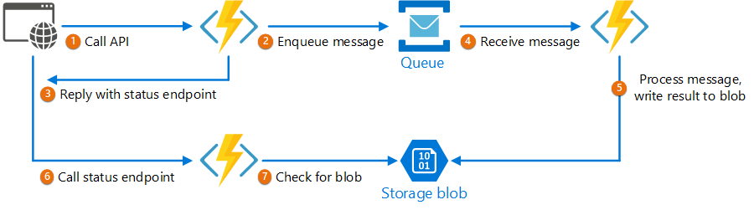
Change synchronous API calls to an asynchronous pattern using Azure Service Bus. This involves decoupling the request initiation from the response delivery. This allows the client to receive an immediate acknowledgment while the actual processing occurs in the background, mediated by Service Bus.
Steps to achieve this:
- Client initiates requests and receives immediate acknowledgment:
- The client sends its request to an API endpoint (e.g., a Web API or Azure Function).
- Instead of performing the full processing synchronously, this API immediately publishes a message to an Azure Service Bus queue or topic, containing the request details.
- The API then returns an immediate response to the client (e.g., HTTP 202 Accepted), indicating that the request has been received and will be processed asynchronously.
- A separate worker process or Azure Function subscribes to the Service Bus queue/topic and consumes the messages.
- This consumer performs the actual business logic and processing of the request.

https://learn.microsoft.com/en-us/azure/architecture/patterns/async-request-reply

Web Pub Sub
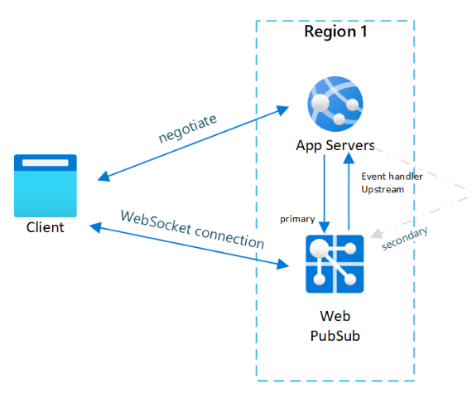

Async HTTP APIs (Durable Functions workflow)
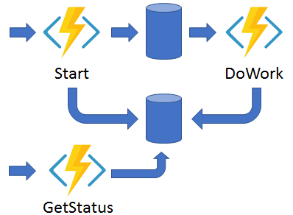

“The async HTTP API pattern addresses the problem of coordinating the state of long-running operations with external clients. A common way to implement this pattern is by having an HTTP endpoint trigger the long-running action. Then, redirect the client to a status endpoint that the client polls to learn when the operation is finished.
Durable Functions provides built-in support for this pattern, simplifying or even removing the code you need to write to interact with long-running function executions. For example, the Durable Functions quickstart samples (C#, JavaScript, TypeScript, Python, PowerShell, and Java) show a simple REST command that you can use to start new orchestrator function instances. After an instance starts, the extension exposes webhook HTTP APIs that query the orchestrator function status.”
https://learn.microsoft.com/en-us/azure/azure-functions/durable/durable-functions-overview?tabs=in-process%2Cnodejs-v3%2Cv1-model&pivots=csharp

Event Consolidation and Tracking

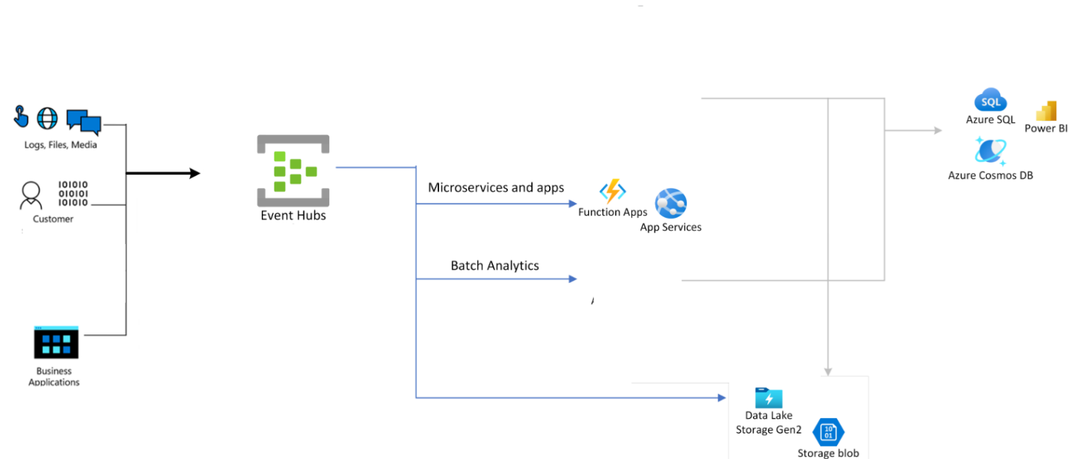

An event is created by a publisher such as a Blob Storage account, Event Hubs or even an Azure subscription. As events occur, they’re published to an endpoint called a topic that the Event Grid service manages to digest all incoming messages.
If they can post an HTTP request to the Event Grid service, then they’re candidates for sending events.
These highlight some of the emerging serverless technologies on Azure, such as Functions and Logic Apps. In addition to Azure Automation, another type of event handler could be any HTTP callback, also referred to as a Webhook.
https://learn.microsoft.com/en-us/archive/msdn-magazine/2018/february/azure-event-driven-architecture-in-the-cloud-with-azure-event-grid

Microservice Patterns

Overall Design
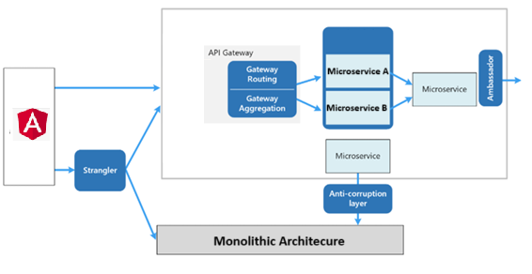
Microservices is an architectural style that structures an application as a collection of small, independent services. Each service focuses on a specific business capability and communicates with others through well-defined APIs, enabling independent development, deployment, and scaling.
- Independent Services:
Each microservice is a self-contained unit responsible for a specific function or business capability.
- Lightweight Communication:
Services communicate with each other through APIs, often using protocols like REST.
- Fault Isolation:
If one service fails, it doesn't necessarily bring down the entire application, improving overall resilience.

https://learn.microsoft.com/en-us/azure/architecture/microservices/design/patterns

DDD
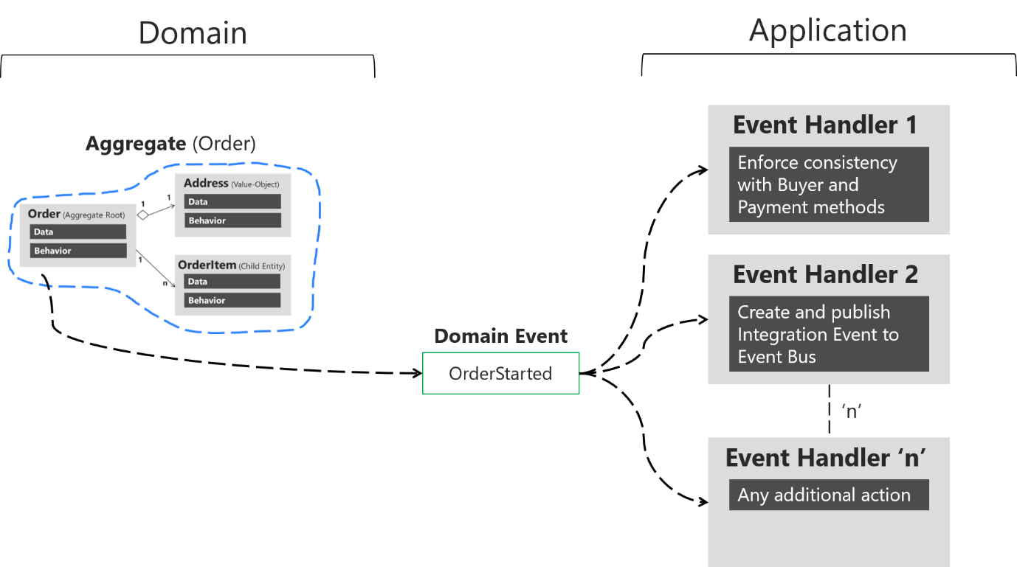

DD D is a software development approach that centers the design and development of a software system around the core business domain. It emphasizes understanding the business domain deeply and modeling the software to accurately reflect its complexities and nuances. This approach aims to create a shared understanding of the domain among all stakeholders (business experts, developers, etc.) using a ubiquitous language.
https://learn.microsoft.com/en-us/dotnet/architecture/microservices/microservice-ddd-cqrs-patterns/ddd-oriented-microservice

CRQS
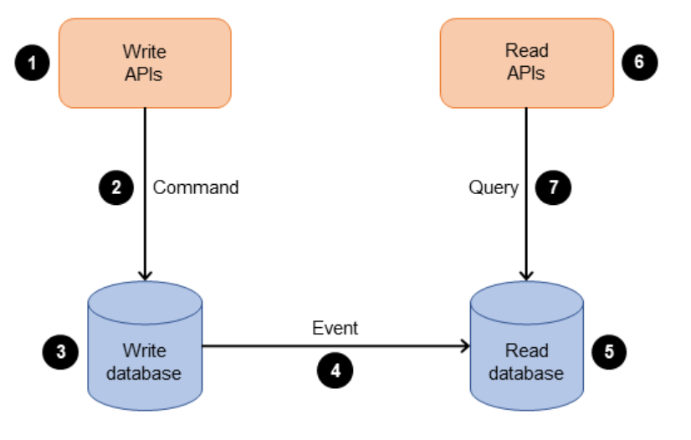
- The business interacts with the application by sending commands through an API. Commands are actions such as creating, updating, or deleting data.
- The application processes the incoming command on the command side. This involves validating, authorizing, and running the operation.
- The application persists the command’s data in the write (command) database.
- After the command is stored in the write database, events are triggered to update the data in the read (query) database.
- The read (query) database processes and persists the data. Read databases are designed to be optimized for specific query requirements.
- The business interacts with read APIs to send queries to the query side of the application.
- The application processes the incoming query on the query side and retrieves the data from the read database.
https://docs.aws.amazon.com/prescriptive-guidance/latest/modernization-data-persistence/cqrs-pattern.html

Circuit breaker
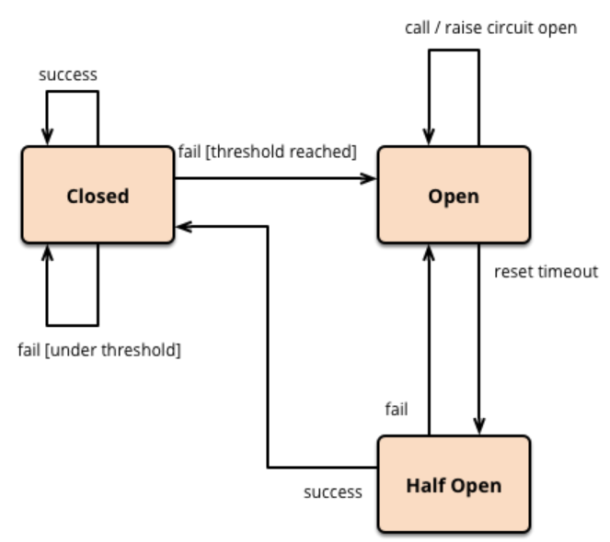
It is used to prevent cascading failures. It acts as a proxy, monitoring the success and failure of operations, and temporarily blocking further requests to a failing service once a predefined threshold of failures is reached. This prevents the entire system from being overwhelmed by a failing dependency.
- The Circuit Breaker wraps a potentially failing operation (like a remote service call).
- It monitors the success and failure of these calls.
- When failures exceed a certain threshold, the circuit "trips," blocking further calls to the failing service.
- After a timeout period, the circuit "half-opens," allowing a limited number of requests to test if the service has recovered.
- If the tests succeed, the circuit closes, and normal operation resumes.
- If the tests fail, the circuit remains open, and the process repeats.
https://learn.microsoft.com/en-us/azure/architecture/patterns/circuit-breaker

Bulkhead
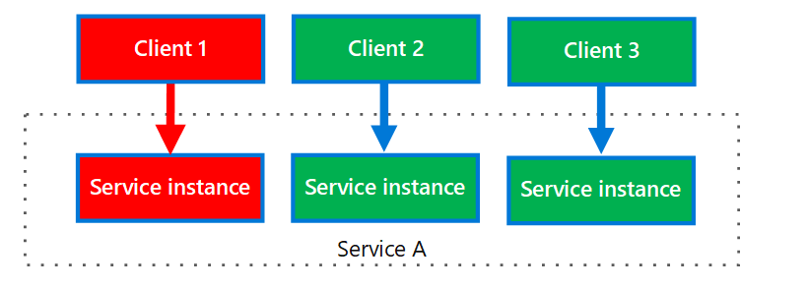
The Bulkhead Pattern is a design pattern used to improve fault tolerance in distributed systems, particularly in microservices architectures. It isolates components or services, preventing failures in one part of the system from cascading and causing widespread outages. This isolation is achieved by limiting the resources allocated to each component, such as thread pools or database connections.
https://learn.microsoft.com/en-us/azure/architecture/patterns/bulkhead

Saga

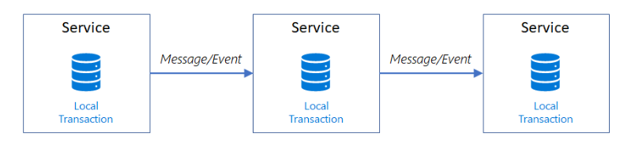
The saga pattern is a design pattern used in microservices architecture to manage data consistency across multiple services during distributed transactions. It involves a sequence of local transactions, where each transaction updates the database and potentially triggers the next one in the sequence. If a local transaction fails, compensating transactions are executed to undo the changes made by previous successful transactions, ensuring eventual consistency.
- Local Transactions:
Each service in the saga performs its own local transaction, updating its own database.
- Eventual Consistency
Unlike traditional ACID transactions, data inconsistencies might exist temporarily during the saga execution, but they are eventually resolved.
- Compensating Transactions
If a local transaction fails, compensating transactions are executed to roll back the changes made by the successful transactions before it.
- Orchestration
A central coordinator (orchestrator) manages the saga flow, sending commands to each service and receiving responses.
https://learn.microsoft.com/en-us/azure/architecture/patterns/saga

Strangler Fig
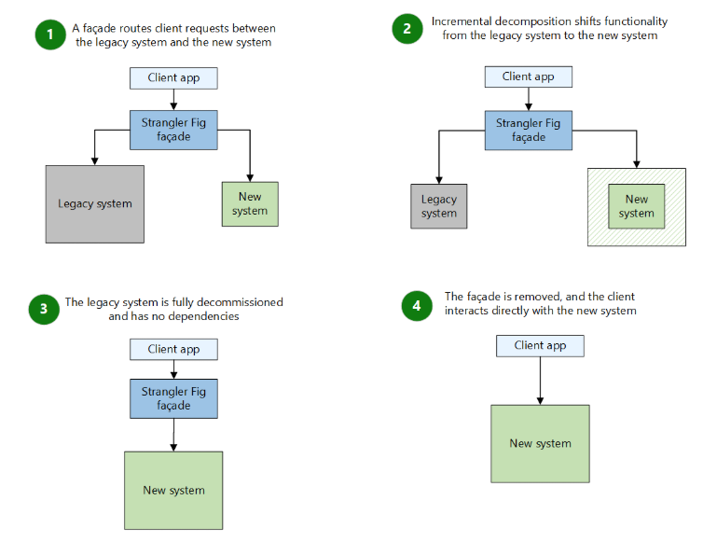 This pattern incrementally migrates a legacy system by gradually replacing specific pieces of functionality with new applications and services. As you replace features from the legacy system, the new system eventually comprises all of the old system's features. This approach suppresses the old system so that you can decommission it.
https://learn.microsoft.com/en-us/azure/architecture/patterns/strangler-fig

Aggregation
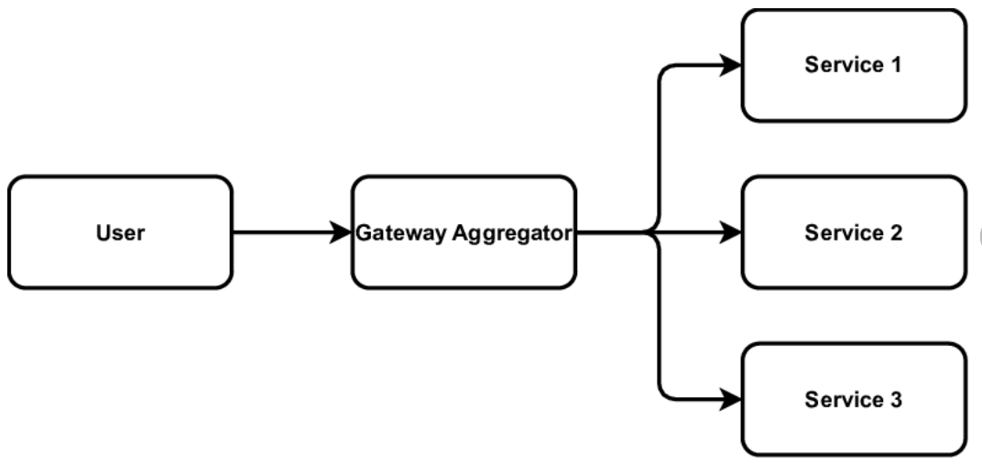
To perform a single task, a client may have to make multiple calls to various backend services. An application that relies on many services to perform a task must expend resources on each request. When any new feature or service is added to the application, additional requests are needed, further increasing resource requirements and network calls. This chattiness between a client and a backend can adversely impact the performance and scale of the application. Microservice architectures have made this problem more common, as applications built around many smaller services naturally have a higher amount of cross-service calls.
https://learn.microsoft.com/en-us/azure/architecture/patterns/gateway-aggregation

Gateway Routing
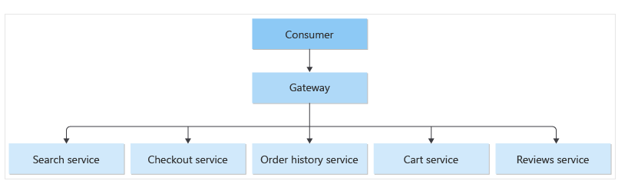
When a client needs to consume multiple services, multiple service instances or a combination of both, the client must be updated when services are added or removed. Consider the following scenarios.
https://learn.microsoft.com/en-us/azure/architecture/patterns/gateway-routing

Queue Based Load Leveling Pattern
“Use a queue that acts as a buffer between a task and a service it invokes in order to smooth intermittent heavy loads that can cause the service to fail or the task to time out. This can help to minimize the impact of peaks in demand on availability and responsiveness for both the task and the service.”
https://learn.microsoft.com/en-us/azure/architecture/patterns/queue-based-load-leveling

Cross-cutting Components

- Validation: classes and attributes to handle validation easily.
- Gate Checking: classes and attributes to handle comparison of expected results vs actual.
- Domain Model: DDD base classes for app services, domain services, domain repositories, entities, specifications, and composite roots.
- Encryption: classes to perform encryption/decryption according to Platform and App use cases.
- Configuration: classes providing configuration infrastructure and change detection.
- Jobs: orchestrator, implementation base classes, job monitoring, status tracking and retrying classes.
- Business Domain Capabilities: set of project libraries created to utilize specific domain capabilities of the platform. Including service principal management.
- Logging, Tracing, Auditing and Exception handling: base classes providing those capabilities.

Network Considerations

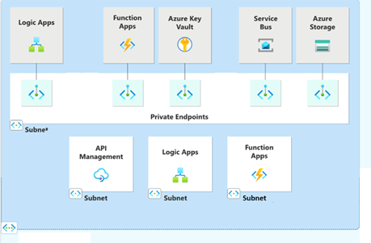
A private endpoint is a network interface that uses a private IP address from your virtual network. This network interface connects you privately and securely to a service that's powered by Azure Private Link. By enabling a private endpoint, you're bringing the service into your virtual network.
- Platform will ensure network level security by creating resources in designated VNETs or limiting IP firewall to well-known list of IP addresses.
- Microservices and Azure functions will be connected to platform Public Endpoints.
- Blob storage and Data Lake Store will be connected to platform Public Endpoints.
- Sensei consists of microservices and an event driven design. Sensei will be deployed in supported geographical regions.

Security
In Azure, security for microservices is based on the Zero Trust principle, using a multi-layered, defense-in-depth approach. This strategy relies on native Azure services to manage identity, secure communication, protect data, and monitor the entire environment.
Foundational strategies
- Implement Zero Trust: Assume that no microservice, user, or device is trustworthy by default. Every transaction must be explicitly verified and authenticated.
Identity and access management
Securing access for both human users and microservice identities is critical in a distributed system.
· Managed identities: Assign managed identities to microservices to authenticate with other Azure resources, like Key Vault or databases, without needing to manage credentials manually.
· Role-Based Access Control (RBAC): Define the principle of least privilege by using RBAC. Grant each identity only the permissions required to perform its function.
- Use tokens for authentication: For service-to-service communication, use OAuth 2.0 and OpenID Connect (OIDC) with JSON Web Tokens (JWTs) for secure and standardized authentication.
Secure communication
- API Gateway: Use Azure API Management as the single entry point for all client requests
- Encrypt data in transit: Enforce Transport Layer Security (TLS) or mutual TLS (mTLS) for all communications.
  - External traffic: Enforce HTTPS for all external API endpoints.
  - Internal traffic: Implement mTLS to authenticate and encrypt traffic between microservices. Dapr can automate mTLS.
- Segment networks: Use Azure virtual networks (VNets) to isolate microservices from the public internet.
  - Network Security Groups (NSGs): Control network traffic by creating NSG rules that allow only necessary traffic between services and subnets.
  - Private Link: Securely access Azure PaaS services like Azure Key Vault and Azure Cosmos DB from within your private network.
- Protect against DDoS attacks: Enable Azure DDoS Protection to defend
Data protection
Securing sensitive data, both at rest and in motion, is a top priority.
- Store secrets securely: Use Key Vaults
- Encrypt data at rest: Ensure data stored in databases, storage accounts, and file systems is encrypted
- Use database-level isolation: Implement a dedicated database for each microservice to prevent a breach in one service from compromising data belonging to another.
Monitoring and threat detection
Microservice architectures require a centralized approach to monitoring and auditing to manage complexity.
- Centralize logs and metrics: Aggregate logs from all microservices into a central location to Log Analytics.
- Use Microsoft Defender for Cloud: Manages security and provides cloud workload protection, including recommendations and threat detection for containers.
- Monitor container security: Actively scan container images for vulnerabilities in your Azure Container Registry before they are deployed.
Code and dependency security
Address security risks in the application code and its dependencies.
- Scan for vulnerable dependencies: Use Sonar Cube to continuously scan your application's source code and third-party libraries for security vulnerabilities.
- Harden container images: Use minimal, trusted base images and remove unnecessary components to reduce the attack surface

Risks

DB Risk: Monolithic Schema Design
The current monolithic schema is highly dependent on a common schema. This schema will need to be incrementally denormalized with each new domain. It was suggested that we can use logical domains. Once a working pattern with logical domains is created, we can in the future move to separate databases.

Risks for Microservices
- Larger Attack Surface:
More services and communication points mean more potential entry points for attackers, increasing the risk of unauthorized access, data breaches, and denial-of-service attacks.
Implementing consistent security policies across multiple services with varying configurations and data flows can be challenging.
- Increased Complexity:
Managing and maintaining a distributed system with numerous independent services can be more complex than managing a single monolithic application.
- Data Fragmentation:
Data can become fragmented across different services, making it harder to manage and analyze.

Risk for Event Driven Systems
- Debugging
The asynchronous nature of Event Driven Architectures makes debugging difficult. Tracing event flows and identifying the root cause of issues can be challenging.
- Idempotency
Failing to handle idempotency can lead to duplicate event processing and inconsistent states.
- Error Handling
Handling errors and exceptions in an Event Driven Architectures can be more complex due to the asynchronous nature of events.
- Testing
Testing Event Driven Architectures systems can be challenging due to the potential for unforeseen interactions and permutations.

Developer Tooling & Framework Standards
1. Purpose
Establish a consistent, auditable, and high-quality developer experience for all K12 Sensei microservices. This document codifies the minimum required tooling, project structure, testing layers, local development workflow, and quality/security gates so that new services are production-ready by construction.
2. Scope
- Service scaffolding templates and repository layout
- Supported runtimes, frameworks, and base container images
- Local development workflow (Dapr, emulators, environment config)
- TBD
- Integrate/replace powershell orchestration(s) with Aspire.net
- Generate deployment manifests (artifacts) with Aspire for target environments
- Tooling catalog (build, test, quality, security, observability)
- Mandatory quality gates and coverage thresholds (TBD)
- Test strategy (unit, contract, integration, performance smoke)
- Secret handling and configuration hygiene
- Governance hooks (pre-commit, CI/CD gates) (TBD)
3. Goals & Success Metrics
Goal | Metric / Target
Fast Onboarding | New engineer productive (PR merged) ≤ 60 min
Consistent Quality | Sonar "no new critical/blocker issues" enforced
Early Security | 0 committed secrets (Gitleaks)
Reliable Contracts | Contract test failures block merge 100%
Observability Baseline | 100% services emit RED metrics + tracing upon first run

5. Supported Language & Runtime Matrix
Layer | Primary | Policy | Notes
Backend APIs &Workers | .NET 8 (LTS) | Mandatory | Evaluate Native AOT (Phase 2 performance)
Workflow / Orchestration | Durable Functions (.NET 8) + Dapr Workflow (eval) | Allowed | ADR required before switching primary
Front-end | Angular (current LTS) | Mandatory | Node version pinned via .nvmrc
Scripting / Infra | PowerShell, Bash, Terraform | Mandatory | Terraform authoritative for infra
Container Runtime Base | mcr.microsoft.com/dotnet/aspnet:8.0-alpine | Mandatory | Weekly digest refresh PR
6. Standard Service Template
A k12-cli (internal) or dotnet new k12.api generator produces:
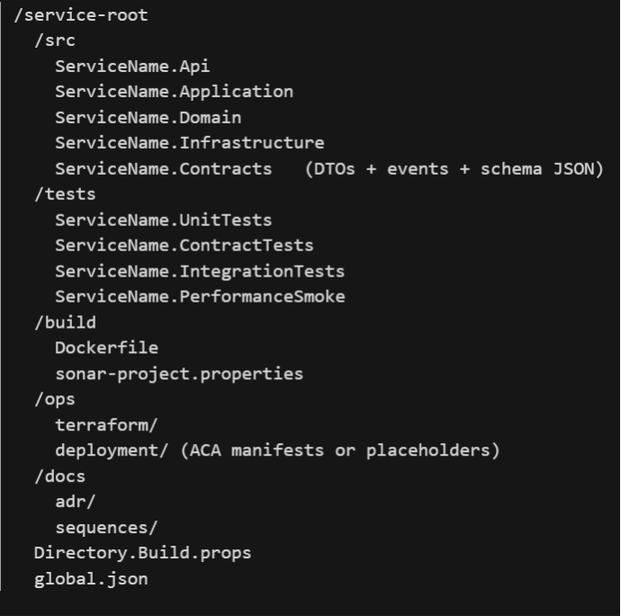
Layer Responsibilities:
- Domain: Pure domain model + invariants (no external references)
- Application: Use cases (commands/queries), orchestration logic
- Infrastructure: Persistence (EF Core or repository), messaging adapters, external API clients
- API: Transport concerns (controllers, validation, mapping)
- Contracts: Message definitions, schema JSON used in validation & contract tests
7. Project Conventions
Concern | Convention | Rationale
Namespaces | Company.{Project}.{BoundedContext}.{Layer} | Consistent resolution
DTO Mapping | Mapster or Manual Profiles (no reflection automagic) | Performance & explicitness
Validation | FluentValidation | Uniform error shape
Configuration | IOptions + validation on startup | Fail fast
Health Endpoints | /health/live & /health/ready | Platform probes
OpenAPI | Swashbuckle w/ minimal docs | Contract visibility
Error Shape | ProblemDetails (RFC 7807) | Standardization
Logging | Structured (Serilog or built-in + OTel) | Queryable
Tracing | OpenTelemetry (W3C traceparent) | Cross-service correlation
Messaging | Dapr pub/sub abstraction | Decouple from direct SDK
Integrity | integrityHash on envelope | Tamper detection
8. Quality Gates (Local & CI)
Layer | Tool | Threshold / Rule | CI Enforcement
Formatting (.NET) | dotnet format | No diffs | Yes (fail)
Lint (Angular) | ESLint + Prettier | No errors | Yes
Static Analysis | Roslyn + SonarQube | No new critical/blocker | Yes
Code Coverage | Coverlet | ≥ 70% lines (raise to 80% Phase 2) | Yes
Vulnerability Scan | Trivy | 0 Critical; High requires waiver | Yes
Secrets | Gitleaks | 0 findings | Yes
Contract Tests | Pact + schema validation | All passing | Yes
Build Reproducibility | Deterministic flags | Hash stable | Yes (hash diff check)
Idempotency Compliance | Analyzer (custom) | Mandatory attribute where required | Yes (warn→fail Phase 2)
9. Testing Strategy
Layer | Purpose | Scope | Trigger | Notes
Unit | Domain integrity | Aggregates, value objects | Every build | <100ms/test ideal
Contract (REST) | Provider-consumer alignment | Pact interactions | PR + nightly | Fails merge if drift
Contract (Events) | Envelope shape & schema | JSON schema validation | PR + nightly | AsyncAPI future
Integration | Infra boundaries | DB, message bus pub/sub | Selective on PR | Full nightly
Performance Smoke | Regression guard | 5–10 scripted endpoints | Pre-prod deploy | k6 minimal load
Security Static | Dependencies & secrets | FS & image scan | Every build | Trivy + Gitleaks
Resiliency (Phase 2) | Failure handling | Chaos inject tests | Quarterly | Chaos Studio/Dapr faults
Coverage Reporting:
- Aggregated via ReportGenerator (lcov + HTML)
- Published as pipeline artifact
- Trend tracked in Quality dashboard
10. Local Development Workflow
Golden path:
- Clone repository
- Run ./bootstrap.(ps1|sh) (installs SDK versions, Dapr, commit hooks)
- Start dependencies: dapr run or docker compose up
- Launch service: dapr run --app-id awarding-api -- dotnet run --project src/Awarding.Api
- Execute tests: make test or dotnet test
- View coverage: make coverage
- Build container: make image
- Run Trivy scan: make scan
10. Secret & Configuration Handling
Concern | Dev Approach | Production Approach | Rule
App Secrets | dotnet user-secrets or .env (gitignored) | Key Vault + Managed Identity | Never in repo
Connection Strings | Env var override | Key Vault reference | Must support rotation
API Keys | Rotated dev keys (low-priv) | Managed Identity preferred | Expire ≤ 90 days
Certificates | Self-signed dev trust | Issued + rotated | No wildcard in prod
Feature Flags | Env bools (temp) | Central config (App Config future) | Document toggles
11. Dapr (Local Minimal Set)
Capability | Component | Purpose
Pub/Sub | Azure Service Bus (dev namespace) or in-memory fallback | -
State Store | Redis (container) | Ephemeral counters / throttling
Secrets | Key Vault binding | -
Tracing | OTel exporter | -
12. Tooling Matrix (Authoritative Extract)
Category | Tool | Mandatory | Version Policy | Owner
Build | .NET SDK 8 | Yes | Global.json pinned | Platform
Build Orchestration | Make / PowerShell scripts | Yes | Script repo | Platform
Container Build | Docker BuildKit | Yes | ≤ 2 minors behind | DevOps
Pub/Sub Abstraction | Dapr CLI | Yes | Latest stable | Platform
Static Analysis | Roslyn + SonarQube | Yes | Quality profile locked | Architecture
Contract Testing | Pact | Yes | Broker pinned | QA
Message Schema Validation | Custom schema validator (JSON) | Yes | Synchronized | Architecture
Security Scan | Trivy | Yes | Weekly update | Security
Secret Scan | Gitleaks | Yes | Monthly update | Security
SBOM | Syft | Yes | Latest minor | Security
Coverage | Coverlet | Yes | Locked minor | Dev Leads
Load (Smoke) | k6 | Conditional | LTS binary | Performance
Observability | OpenTelemetry SDK + Collector | Yes | Pinned minor | Platform
13. Command Cheat Sheet (for local & CI/CD cmds)
Task | Command
New Service | K12-cli new service --name Awarding
Restore & Build | dotnet build
Run API | dapr run --app-id awarding-api -- dotnet run --project src/Awarding.Api
All Tests | make test
Contract Tests | dotnet test tests/Awarding.ContractTests
Format Code | make format
Generate Coverage | make coverage
Build Image | docker build -t k12/awarding-api:dev .
Scan Image | trivy image k12/awarding-api:dev
Generate SBOM | syft k12/awarding-api:dev -o spdx-json > sbom.json
Run Lint (Angular) | npm run lint
Publish Pact | npm run pact:publish or .NET pact CLI
14. Governance & Automation Hooks
Stage | Hook | Enforcement
Pre-Commit | Format + lint + fast secret scan | Developer machine
Push (PR) | Build + unit + contract + coverage | Mandatory
PR Gate | SonarQube quality gate + Trivy scan | Must pass
Merge to Main | Full integration tests + image publish | Blocking failures
Promotion | Synthetic tests + manual approval (initial) | Terraform plan reviewed (TBD)
15. Observability Requirements (Per Service)
Requirement | Description
RED Metrics | request_rate, request_error_rate, request_duration_p95
Domain Metrics | awarding_batches_completed_total (if domain relevant)
Tracing | 100% non-prod, 20% head + tail in prod
Logging | Structured + correlationId + traceId
Integrity Metrics | integrity_hash_mismatch_count exported
16. Idempotency & Integrity Enforcement
- Idempotency required for every message consumer (duplicate detection data store).
- integrityHash computed: canonical JSON payload (sorted keys) + messageId → SHA-256 hex (prefixed sha256:).
- Analyzer (Phase 1) ensures Consumer handlers are Idempotent; violations reported.
17. Security Controls (Developer Workflow)
Control | Mechanism | Failure Handling
Secret Leakage | Gitleaks | Pipeline fail
Vulnerabilities | Trivy | Fail on Critical
Supply Chain (Phase 2) | Image signing | Block unsigned
Authorization Checks | Integration tests w/ sample tokens | Test failure
PII Logging Guard | Structured logging filters | Failing test if pattern matched
18. Onboarding Golden Path (≤ 60 Minutes)
Step | Time | Outcome
Bootstrap environment | 5m | SDKs & Dapr installed
Run template service | 5m | Local API up
Execute tests | 10m | Green tests & coverage
Add endpoint + unit test | 15m | Pattern comprehension
Add contract test & publish | 10m | Pact in broker
Build & scan container | 10m | Security integrated
Review pipeline YAML | 5m | Understand gates
19. Drift Management
Quarterly automation:
- Compare active services vs template manifest (hash of canonical file list + baseline).
- Generate drift report: missing analyzers, outdated Dockerfile base digest, absent OTel exporter.
- Create remediation tickets (SLA: 1 sprint for critical drift, 2 sprints for minor).
20. Risks & Mitigations
Risk | Impact | Mitigation
Tool Sprawl | Inconsistent builds | Central catalog + ADR approval
Skipped Contract Tests | Runtime incompatibility | Pipeline hard gate
Over-reliance on Defaults | Hidden security gaps | Security review checklist
Performance Blindness | Latency regressions | Mandatory performance smoke stage
Template Divergence | Increased maintenance | Drift audit & auto PR suggestions
21. Backlog (Related Stories)
Ref | Title | Priority
DEVTOOL-001 | Publish k12-cli template package | High
DEVTOOL-002 | Implement custom idempotency analyzer | High
DEVTOOL-003 | Add integrityHash generator CLI utility | High
DEVTOOL-004 | Pact broker container + seed example | High
DEVTOOL-005 | Dapr local profile script (multi-service) | Medium
DEVTOOL-006 | Template drift auditor job | Medium
DEVTOOL-007 | Coverage trend dashboard | Medium
DEVTOOL-008 | Security waiver tracking automation | Medium
22. Acceptance Criteria (Representative)
- Creating new service via k12-cli new service yields compiling solution with passing unit tests, coverage ≥ 70%.
- Contract test failing on provider side blocks merge.
- Pushing code with an embedded secret (test string) fails CI.
- Running local template produces OpenAPI doc at /swagger and /health endpoints reachable.
- integrityHash CLI tool produces identical hash for same payload across dev machines.
23. Future Enhancements (Phase 2+)
Enhancement | Rationale
Tail-based sampling (OTel) | Reduce trace cost while preserving anomalies
Policy as Code (OPA) | Enforce Terraform & container policies
Native AOT edge services | Reduced cold start & memory
AsyncAPI documentation for events | Improve event contract clarity
Automatic golden-path generator dashboard | Visual onboarding status
24. Compliance Mapping (Selected)
Requirement | Implementation
Auditability | Git history + signed image digest (Phase 2)
Least Privilege | Service principal / Managed Identity per service
Data in Transit Encryption | TLS enforced; no HTTP fallback
No Secrets in Code | Gitleaks + pre-commit + reviews
Traceability | CorrelationId mandated in middleware
25. Change Management
- Minor version increments: additions or clarifications (no breaking structure).
- Major version increments: structural changes to template, new mandatory tools, or coverage threshold increase.
- All major changes require Architecture Board approval + broadcast.
26. Readiness Checklist (Per Service Before First Deploy)
Item | Pass
Uses standard template structure | ☐
Health endpoints implemented | ☐
OpenTelemetry enabled (traces + RED metrics) | ☐
Contract tests published & validated | ☐
Coverage ≥ threshold | ☐
Dockerfile matches approved base digest | ☐
Trivy scan clean (no Critical) | ☐
integrityHash enforced in message publisher (if applicable) | ☐
Idempotent consumer attribute applied (if applicable) | ☐
No secrets detected by Gitleaks | ☐

Testing
Load testing Azure microservices typically involves using Azure Load Testing, a fully managed load-testing service that allows you to generate high-scale load and analyze application performance.

- Create an Azure Load Testing Resource:
  - Create a new Azure Load Testing resource, providing details like subscription, resource group, name, and region.
- Create a Load Test:
- URL-based test: If you have a simple scenario and want to test a single URL, you can define the request details directly in the portal.

    - Script-based test: For more complex scenarios involving multiple requests, authentication, or dynamic data, you can upload a test script. Azure Load Testing supports Apache JMeter and Locust scripts.
- Configure the Load Test:
  - Load Pattern: Define the number of virtual users, ramp-up period, and test duration to simulate the desired load.
  - Target Endpoints: Specify the URLs or endpoints of your Azure microservices that you want to test.
  - Parameters and Secrets: If your microservices require specific parameters, headers, or secrets (e.g., API keys), you can configure them in your script or directly in the Azure Load Testing settings.
  - Failure Criteria: Define conditions under which the test should be considered a failure (e.g., high error rate, slow response times).
- Run the Load Test:
  - Initiate the load test from the Azure portal.
  - Azure Load Testing will provision the necessary test engines and execute your test script, generating load against your microservices.
- Analyze Results:
  - During and after the test run, you can monitor real-time metrics and view detailed results in the Azure Load Testing dashboard.
  - Analyze key performance indicators (KPIs) like response time, throughput, error rate, and resource utilization of your microservices
  - Identify bottlenecks, performance regressions, and areas for optimization within your microservice architecture.
- Iterate and Optimize:
  - Based on the analysis, make necessary adjustments to your microservices for scaling, code optimization, configuration .
  - Rince and Repeat the load testing process

Stress Testing
A performance test that overloads a system until it breaks. Push your workload beyond its normal limits to identify its breaking points and measure its ability to recover. SEAA/CFI has given concurrency and user count for us to baseline for testing. Sensei should minimally be able to handle spikes of heavy activity.
https://learn.microsoft.com/en-us/azure/well-architected/performance-efficiency/performance-test

https://azure.microsoft.com/en-us/products/load-testing

Load Testing
Load testing is critical for confirming that your application can handle expected user traffic by simulating real-world demand. Sensei should minimally be able to handle spikes of heavy activity.
https://learn.microsoft.com/en-us/azure/well-architected/performance-efficiency/performance-test

https://azure.microsoft.com/en-us/products/load-testing

